BIOLOGY PAPER 1 MARKING KEY
SECTION A (70 MARKS)
- a Mention any two significances of osmosis.
- Involved in absorption of water by plants in the roots (1mark)
- provide support to plant tissues (1)
- Enables guard cells to obtain or to lose water (1) any two (2 Marks)
b. Explain one way of mitigating the impact of climate change.
- Planting and conserving trees -Trees absorb carbon dioxide from the atmosphere during photosynthesis.
- Using renewable sources of energy – This does not release large amounts of green house gases. Any one(2marks)
c. Explain how the Fossils records support the theory of evolution.
. past and current fossils are compared (1), resemblance supports evidence of evolution(1).( 2 Marks )
- a. Define tropisms?
Tropism refers to a growth response towards or away from a stimulus coming from one direction. (1mark)
b. explain one importance of phototropism
- enables plant to absorb light(1) for the process of photosynthesis
- it exposes plant flowers to insect (1) for pollination (1)(2 marks)
b. State any two principles of Mendelian genetics
- Alleles of same gene do not blend (1)
- Alleles of same gene pass into separate cell (1)
- Alleles of same gene are inherited independently (1)
- A pair of genes control a character (1) any two (2 marks)
c. Explain any one adaptation of the alveolus to its function.
- has dense network of blood capillaries (i) for efficient transport of gases.
- has film of moisture (1) for dissolving of gases before diffusion
- has thin wall (i) for rapid diffusion of gases
- are numerous (1) to increase surface area for gaseous exchange
any one(2 marks)
3 a. Distinguish between fertilization and conception.
- Fertilization is the fusion of the male and female gametes while conception means to develop or to begin to form something (1mark)
b. Figure 1 is a diagram showing a certain movement in fish.
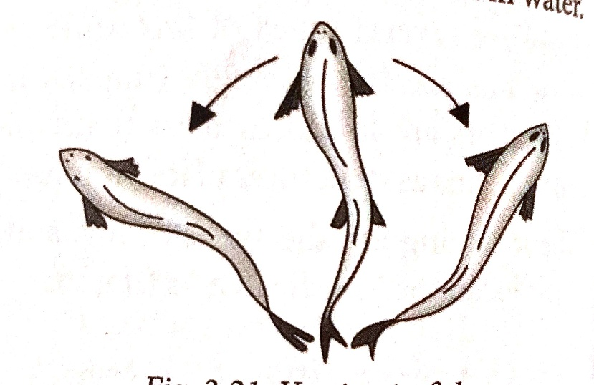
Figure 2
- Identify the movement shown by fish in figure 1.
yawing (1) (1 mark)
- Mention two fins that the fish use to prevent the fish movement in figure 1
- dorsal fin
- Ventral fin (2marks)
c. Explain how red blood cells transport oxygen
by binding oxygen to haemoglobin (1) to be transported in form of oxyhaemoglobin (1) 2 Marks
d. Describe any one abnormal condition of the nervous system.
- polio (1) causes paralysis of muscles (1)
- meningitis (1) attacks meninges of spinal cord and brain (1)
- Leprosy (1) causes permanent damage to skin nerves (1)
- Tetanus (1) causes permanent contraction of muscles (1) any one (2 Marks)
- a. Figure 2 is a diagram, showing two types of respiration in the form of equation P and Q
P: glucose+oxygen→carbondioxide+water+2898kj energy
Q: glucose→ lactic acid+150KJ of energy
(i). write down a balanced chemical equation for equation P
1mark for correct reactants
1mark for correct products
1 mark for balancing(3marks)
(ii). In which part of a cell does equation Q takes place
cytoplasm (1mark)
(iii). Explain the difference in amount of energy produced between equation P and Q
more energy is produced by P than Q (1) because glucose is completely broken down in P to release energy (1) while in Q, some energy is locked up in lactic acid (1)3Marks
- a.Mention the structure that is responsible for the production of folic stimulating hormone in the body.
pituitary gland 1Mark
b. Explain one way in which mitosis cause growth in organism.
when new cells formed increase in number (1) the organism increases in size(1) (2 mark)
c. Explain one effect of water intake on urine production
more intake of water (1) leads to more production of urine (1) and vice versa (2marks)
d. Explain why the patients’ blood and the dialysis fluid move to opposite directions in the dialysis.
they produce concentration gradient(1) for efficient diffusion of waste diffusion of waste substance (1) 2 Marks
e. Give three adaptations of the nephron to its function.
- Presence of numerous microvilli in the proximal convoluted tubule
- Network of blood capillaries
- Thin membrane . (3marks)
- a. Haemophilia is a sex-linked trait. A man who is haemophilic is married to a woman who is heterozygous for this trait. Using an allele H for normal clotting of blood and allele h for haemophilia, draw a genetic cross to show the possibility of giving birth to children who are haemophilic
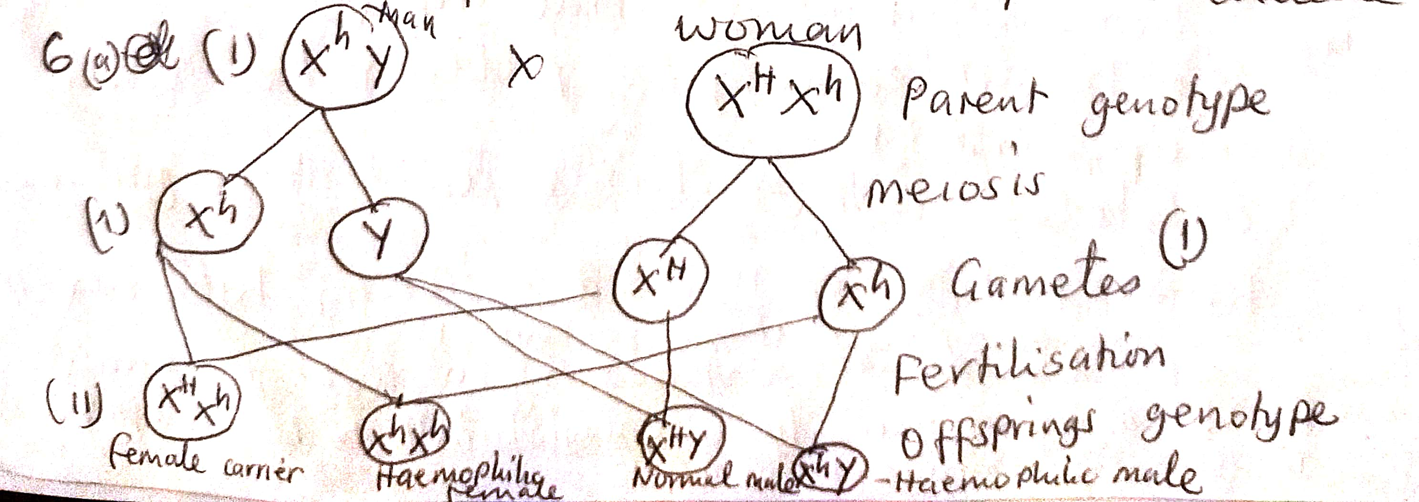 (4marks)
- If a family has eight children, calculate the number of children who will be carriers of haemophilia. Show your working.
Ratio of carrier to non-carriers = 1:3 (1)
Total ratio 1+ 3 = 4
No. of carriers = 1/4 x 8 children
= 2 children (1) (2marks)
7 a.Figure 3 is a diagram of a plant cell as seen through a light microscope.
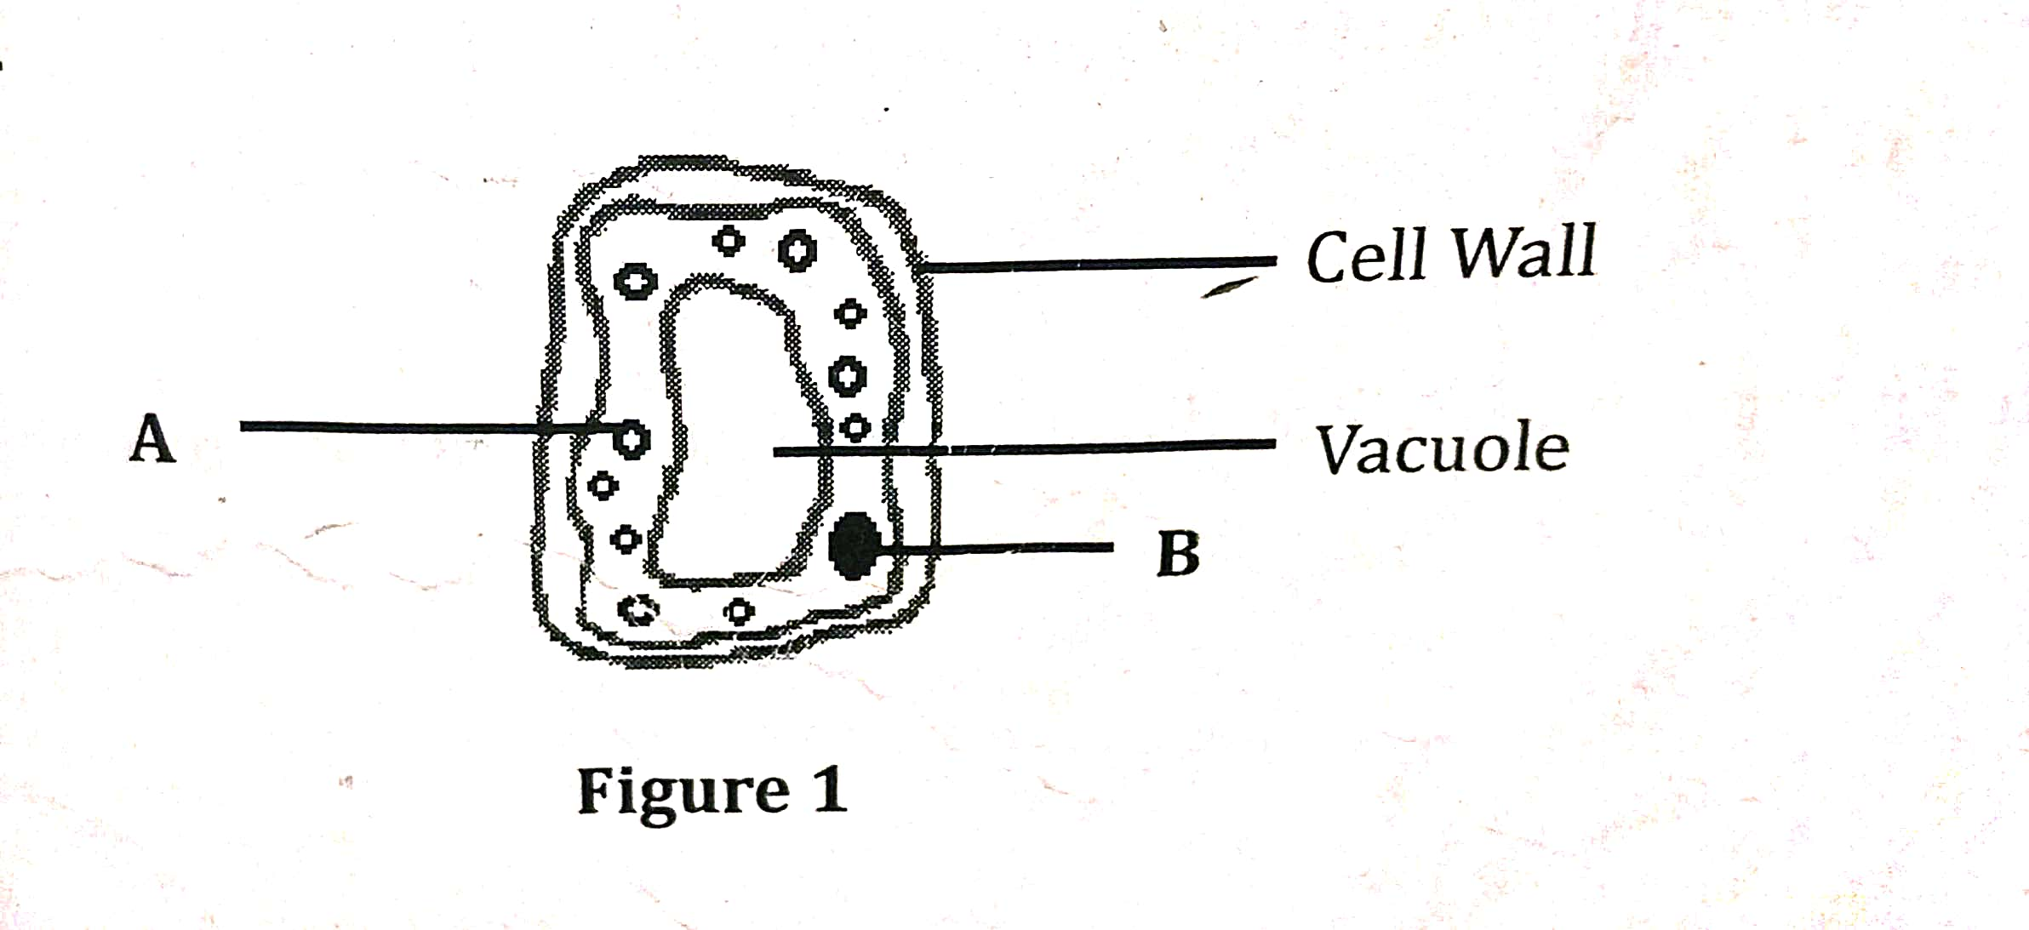
Figure 3
a. Name the part labelled B
B: nucleus (1 mark)
b. What name is given to the cell in figure3
palisade cell (1)1 Mark
c. Explain one adaptation of the cell in figure 3 to its function
- has pores (plasmodesmata) (1) to allow exchange of materials (1)
- has cellulose (1) which resist stretching (1) any one (2 marks)
d. Explain any one factor that affect the rate of diffusion.
- temperature (1)- particles move faster when temperature increases (1) or particles move slowly when temperature decreases
- Concentration of substance (1) -Diffusion is faster when he concentration gradient is high (1)
- Size of molecules (1) – small particles diffuse faster than large particles (1)
- Thickness of membranes (1) -Thin membrane enhance higher rate of diffusion than thick membranes (1)
- Surface area to volume ratio (1)- The higher the ratio the grater the rate of diffusion. (1) any one (2 Marks)
8 a. Figure 4 is a diagram of longitudinal section of phloem tissue
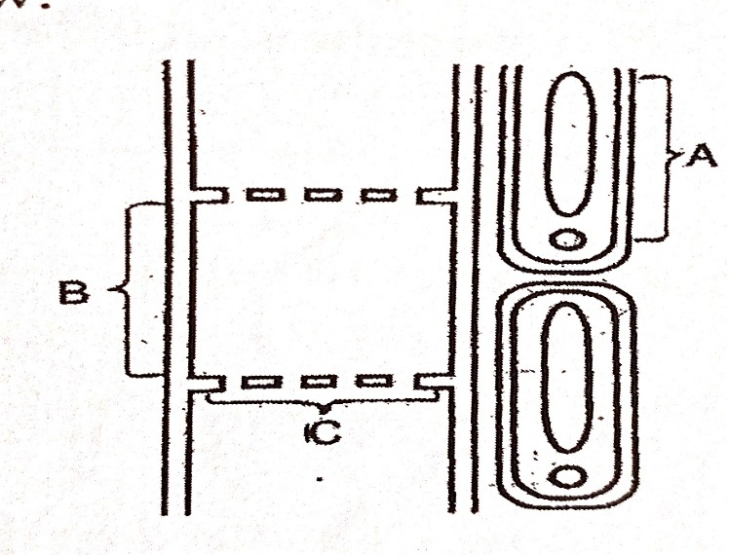
Figure 4
i. Name the parts marked B and C
B. sieve tube (1 mark)
C. sieve plate (1 mark)
ii. Complete the table below to show the two structural differences between xylem and phloem.
Xylem | Phloem
Made of dead tissue | Made of living tissue
No cross walls | Has cross walls
Walls are lignified | Walls not lignified
Made of hollow tubes | Made of sieve elements
(2marks)
iii. State any one function of the part marked A
provides energy for active transport (1 mark)
b. Name any one cell that makes xylem tissue
tracheid
vessel elements any one1 Mark
9 a. Define “passive immunity”.
Passive Immunity: Is immunity acquired by the foetus from the mother by getting antibodies against pathogens through the placenta and also through breast milk. OR. Is the transfer of immunity in the form of ready-made antibodies? OR is the immunity that comes from using antibodies produced in one organism to protect another organism from a specific disease. (1mark)
b. Explain how each of the following helps the body to defend itself against infection.
- Platelets : Form a mesh which is a barrier that seals the opening and initiates the healing process of damaged /injuries tissue hence prevents the entry of disease-causing micro-organism. (2marks)
- Stomach Hydrochloric acid is a strong corrosive chemical produced by gastric glands on the stomach walls which kills bacteria that comes into the stomach with food. The provide immunity against infections. (2marks)
c. Mention any two examples of discontuous variaton
- Gender
- Leaf venation
- Tongue rolling
- Finger print
- Blood groups (2 Marks)
10 a. State any two examples of simple reflex.
- Withdrawing of a hand from a hot object (1)
- sudden blinking of eyes (1)
- construction of pupil (1)
- . secretion of tears (1)
- . sneezing (1) any two (2 Marks)
b. State any two diseases which are caused by fungi in human beings
- athletes foot
- thrush/candidiasis
- ringworm any two (2 Marks)
c. Mention one function of calcium ions at the synoptic knob.
influences movement of vesicles at synoptic knob when an impulse reaches the synapse (1 Mark)

b. Figure 5 is a diagram showing an experimental set up which is left to stand for some hours.
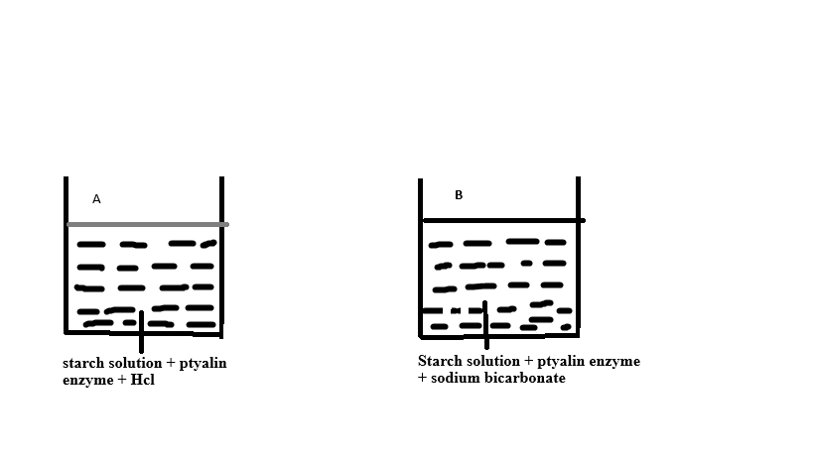
i. State the property of enzyme being investigated in figure 5
Enzymes work under specific PH (1 Mark)
ii. Which set up provides better condition for the work of ptyalin?
set up B (1 Mark)
iii. Describe the result in set up A when iodine solution is added.
It will show blue-black colour (1) since ptyalin has not converted starch to another substance (1 Mark)
SECTION B (30MARKS)
11. Describe how urine is formed
Blood which reaches the glomerulus from afferent arteriole is at high pressure (1). This pressure forces small molecules (1) such as glucose, aminoacids, urea, vitamins to be out into the bowman’s capsule (1). The fluid forced out together with small molecules is glomeruli filtrate (1). This process is called ultrafiltration (1). Then glomeruli filtrate flows down the nephrone (1) where reabsorption takes place (1) of useful substances back into blood (1) through diffusion, active transport and osmosis. Waste substances such as urea, excess water, excess salts, uric acids are not reabsorbed back into blood (1). As the filtrate reaches distal convolution, it is called urine.
12. Describe any five adaptations of leaves to photosynthesis
Have chlorophyll (1) which absorbs sunlight (1)
- Have broad leaf surface (1) to increase surface area for absorption of light and CO2 (1)
- Have network of veins (1) that transport water and manufactured food (1)
- Have regularly arranged mesophyll cell (1) to allow efficient exchange of gases in the leaf cells (1)
- Have transparent cuticle (1) to allow light to penetrate into the leaf cells (1)
- Have stomates (1) to allow air to move in and out of the cells (1)
13. Explain any five ways how adrenaline prepares the body for an action.
- Increases heart rate and blood pressure so that blood flows faster around the body to distribute glucose and oxygen to the muscle cells.
- Constricts arterioles in the skin to facilitate formation of more tissue fluid to the muscle cells to distribute glucose and oxygen for respiration.
- Increases the rate of conversion of glycogen to glucose so that it can be used for respiration
- Increases the rate of breathing so as to take in more oxygen to be used for respiration.
- Dilates pupils for the sight of the stimulus

